University of Wah
Department of Computer Science

Submit to:

Ms. Hassan Shafaqat

Submit by:

Muhammad Talha (101)
Jawad Hussain (108)
Muhammad Rafay Ali (063)

Course:

Computer Network_Lab - CS-241L

Reg No:

UW-24-CS-BS-101
UW-24-CS-BS-108
UW-24-CS-BS-063

Section:

BS-CS-3rd-B

CN Lab Report

Abstract
This project presents the design and implementation of a Software House Network for an organization named SoftTech. The objective of the project is to create a reliable, scalable, and secure network infrastructure that supports multiple departments and common network services such as HTTP, FTP, SMTP, and DNS. The network is designed using a hierarchical model with proper IP addressing, switching, routing, and service configuration. The implementation is carried out using a network simulation tool, and the results demonstrate successful communication, service accessibility, and efficient network management.

1. Introduction
In modern software houses, efficient communication and data sharing are critical for productivity and collaboration. A well-designed computer network enables developers, managers, and servers to interact seamlessly. The SoftTech Software House Network project focuses on designing a structured network that meets real-world organizational requirements, including centralized services, secure communication, and future scalability.

2. Problem Definition
The main problem addressed in this project is the lack of a structured and secure network for a growing software house. The organization requires:
- Centralized network services (Web, Mail, FTP)
- Reliable communication between departments
- Proper IP address management
- Secure and controlled access to network resources
Scope:
The project covers LAN design, IP addressing, service configuration, and basic security.
Constraints:
- Limited hardware resources
- Static topology

3. Literature Review
Existing enterprise network designs commonly use hierarchical architectures consisting of core, distribution, and access layers. Technologies such as VLANs and client-server models are widely used to improve performance and manageability. Previous studies highlight that centralized services reduce configuration overhead and improve scalability, but require proper planning and security mechanisms.

4. System Architecture
The SoftTech network follows a client-server architecture with a hierarchical network model:
- Core Switch: Central backbone of the network
- Access Switches: Connect end devices
- Servers: DHCP, Web, Mail, FTP
- End Devices: PCs and laptops for employees
- 4 Departments: End to end connection
The architecture ensures efficient data flow and easy network expansion.

Screen Shot:
HR Dept
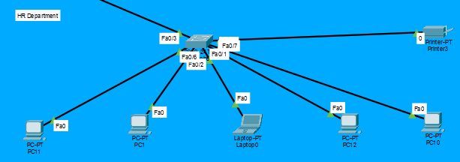
Management Dept
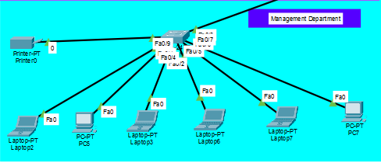
Sales Dept
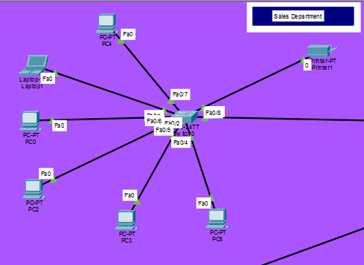
Testing Dept
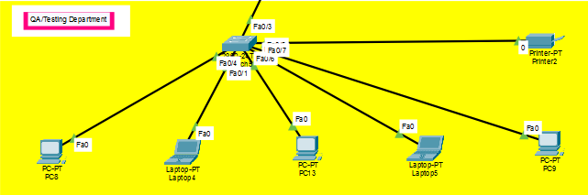

Servers
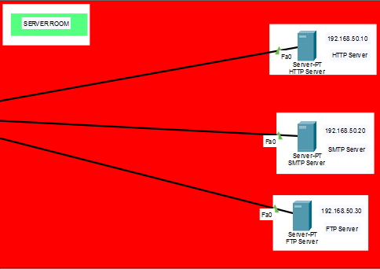
File Uploading (FTP)
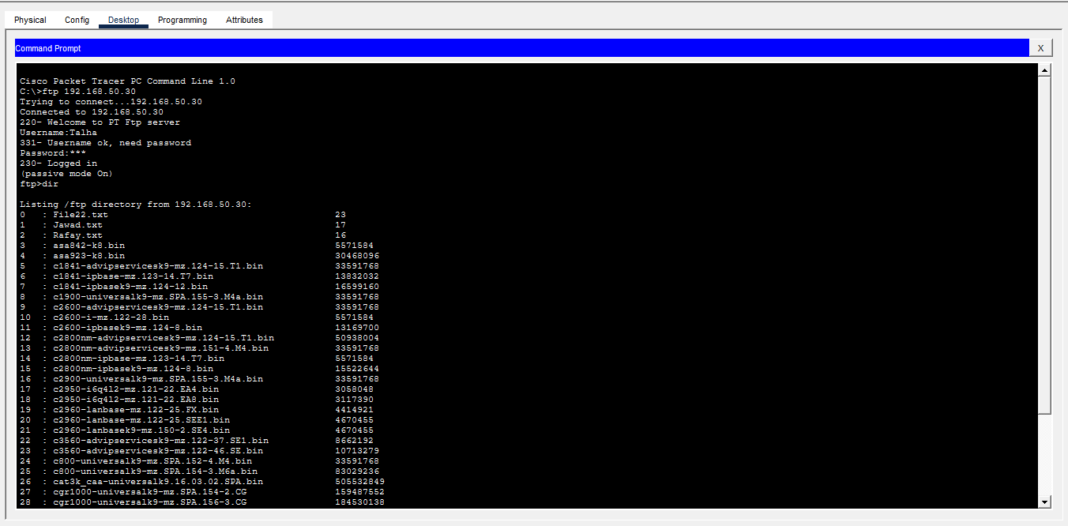

Email Sending (SMTP)
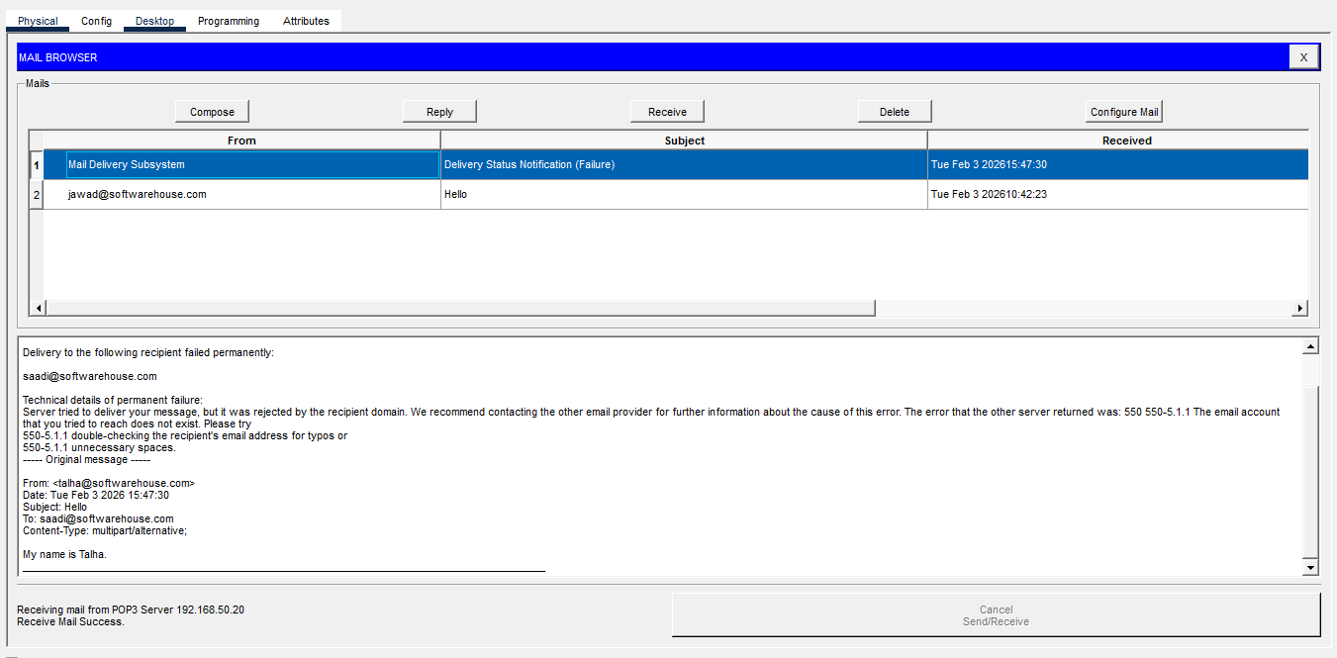
Web Portal (HTTP)
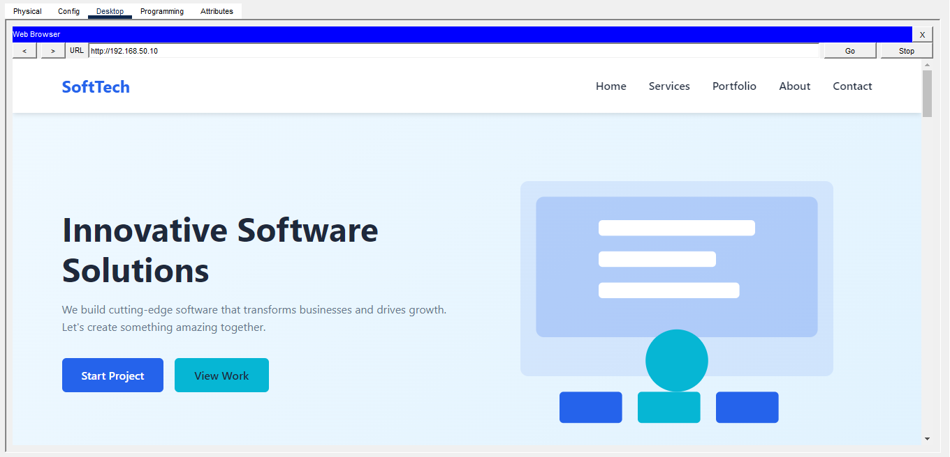

Whole Network
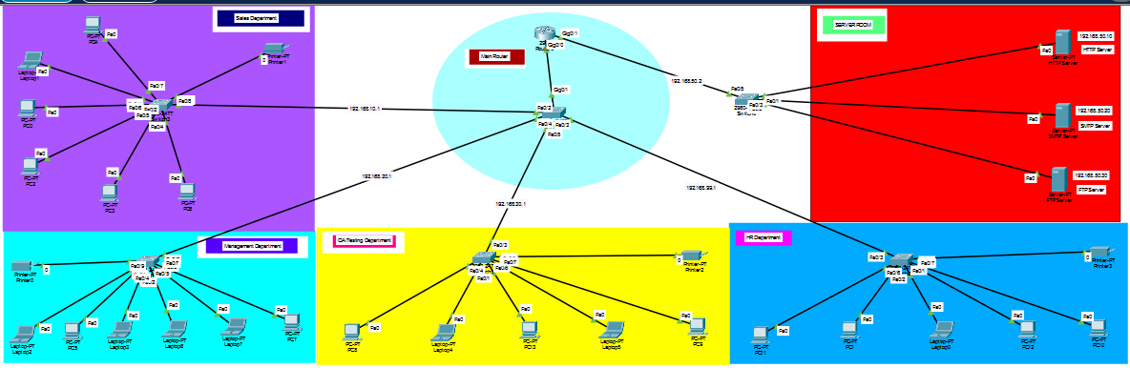

5. Network Design
Topology
A star topology is used within departments, connected through switches.
IP Addressing
- Private IP addressing scheme (e.g., 192.168.1.0/24)
- Static IPs for servers
Switching and VLANs
- VLANs are used to logically separate departments
- Inter-VLAN communication is managed through routing

6. Protocols and Technologies Used
- TCP/IP: Core communication protocol
- HTTP: Web-based services
- FTP: File transfer services
- SMTP & POP3: Email communication
- DNS: Name resolution
These protocols are selected due to their reliability and industry-wide adoption.

7. Implementation Details
The network is implemented using a network simulation tool.
Steps:
- Network topology creation
- IP address assignment
- Switch and router configuration
- DHCP server configuration
- Web, FTP, and Mail server setup
- Testing connectivity and services

8. Performance Evaluation
Network performance is evaluated based on:
- Connectivity: Successful ping between devices
- Service Availability: Access to HTTP, FTP, and Email services
- Response Time: Acceptable latency within LAN
The results show stable and efficient performance.

9. Security Considerations
Basic security measures include:
- Controlled access to servers
- VLAN-based traffic isolation
- Password protection on network devices
These measures help protect the network from unauthorized access.

10. Results and Analysis
The implemented network successfully:
- Assigns IP addresses using static Address
- Allows users to access web and FTP services
- Enables email communication between users
The observed results match the expected outcomes.

11. Discussion
The SoftTech network demonstrates how a properly planned network improves efficiency and manageability. The hierarchical design simplifies troubleshooting and supports future expansion.

12. Challenges and Limitations
- Initial IP addressing issues
- Service configuration errors during setup
- Limited real-hardware testing

13. Applications and Use Cases
- Small to medium software houses
- Office LAN environments
- Educational network simulations

14. Conclusion
This project successfully implements a functional and scalable software house network. It provides hands-on experience with real-world networking concepts, protocols, and services, fulfilling the objectives of the Computer Networks course.

15. Future Enhancements
- Implementation of advanced security
- Wireless network integration
- Network monitoring and logging
- Redundancy and load balancing

16. References
- Andrew S. Tanenbaum, Computer Networks, Pearson Education
- Cisco Networking Academy – Packet Tracer Documentation

